Mango db:

Assignment: 1

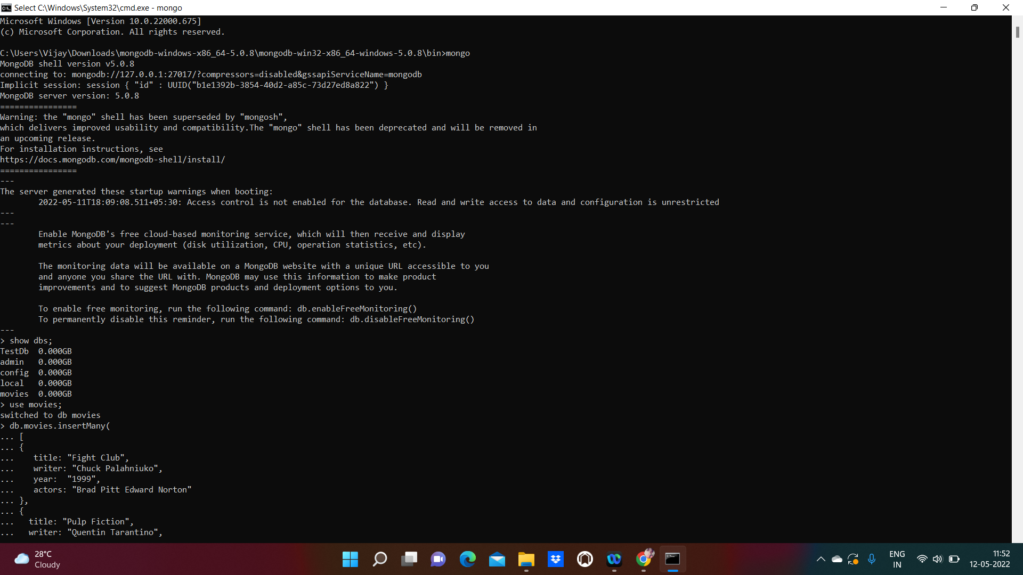



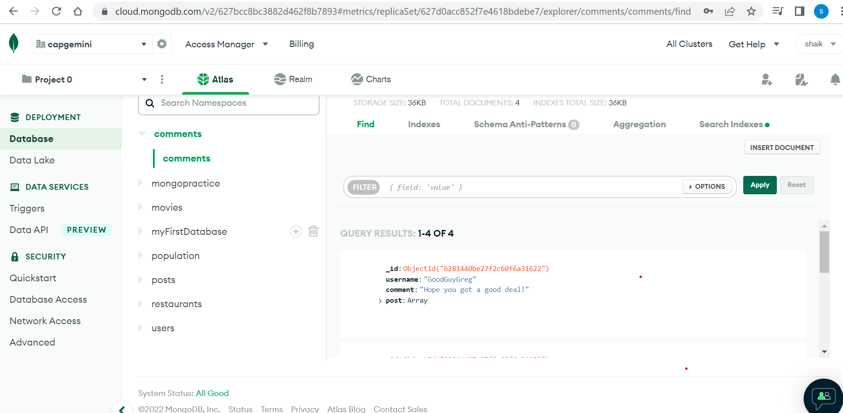

Assignment:2

Atlanta Population

1.db.zipcodes.find({city:"ATLANTA",state:"GA"}).pretty()

2.db.zipcodes.aggregate([{$match:{city:"ATLANTA",state:"GA"}},{$project:{city:1,state:1}}])

3.db.zipcodes.aggregate([{$match:{city:"ATLANTA"}},{$group:{_id:"ATLANTA",count:{$sum:1}}}])

4.db.zipcodes.aggregate([{$match:{city:"ATLANTA"}},{$group:{_id:"ATLANTA",totalPopulation:{$sum:'$pop'}}}])

population by state

1.db.zipcodes.aggregate([{$group:{_id:"$state",totalPopulation:{$sum:'$pop'}}}])

2.db.zipcodes.aggregate([{$group:{_id:"$state",totalPopulation:{$sum:'$pop'}}},{$sort:{totalPopulation:-1}}])

3.db.zipcodes.aggregate([{$group:{_id:"$state",totalPopulation:{$sum:'$pop'}}},{$sort:{totalPopulation:-1}},{$limit:3}])

population by city

1.db.zipcodes.aggregate([{$group:{_id:{state:"$state",city:"$city"},totalPopulation:{$sum:'$pop'}}}])

2.db.zipcodes.aggregate([{$group:{_id:{state:"$state",city:"$city"},totalPopulation:{$sum:'$pop'}}},{$sort:{totalPopulation:-1}}])

3.db.zipcodes.aggregate([{$group:{_id:{state:"$state",city:"$city"},totalPopulation:{$sum:'$pop'}}},{$sort:{totalPopulation:-1}},{$limit:3}])

4.db.zipcodes.aggregate([{$match:{state:"TX"}},{$group:{_id:{state:"$state",city:"$city"},totalPopulation:{$sum:'$pop'}}},{$sort:{totalPopulation:-1}},{$limit:3}])

Bonus

1.db.zipcodes.aggregate([{$group: { _id: {state: "$state"},state:{'$first':'$state'}, count:{$sum:1}, population: {$sum: "$pop"}}},{ $project: { _id:'$state', avg: {$divide:["$population","$count"]}}}])

2.db.zipcodes.aggregate([{$group: { _id: {state: "$state"},state:{'$first':'$state'}, count:{$sum:1}, population: {$sum: "$pop"}}},{ $project: { _id:'$state', avg: {$divide:["$population","$count"]}}},{$sort:{avg:-1}},{$limit:3}])

Assignment:3

